Dealer Deposits
Scenario: G&W makes direct sales to sub dealer Akasaka and on due date he doesn’t pay so it is adjusted from the deposits of shah sales.

S.NO. : 02- FI-AR- 11

Step 1: Acceptance of Dealer Deposits

TRANSACTION CODE : F – 29

ACCESS PATH :SAP Easy Access Accounting Financial
Accounting Accounts Receivable Document Entry
Down payment Down Payment

We get “ Post Customer Down Payment” Header data” screen;

Required Fields:

Document date : To be entered
Account : To be entered (Customer A/c Number)
Spl. G/L Ind. : To be set at “D” (Dealer Deposits)
Post date : Default
Amount : To be entered

Rest all other fields viz, Doc Type, Period, Company code, Currency/Rate are default after they are entered for the first time.

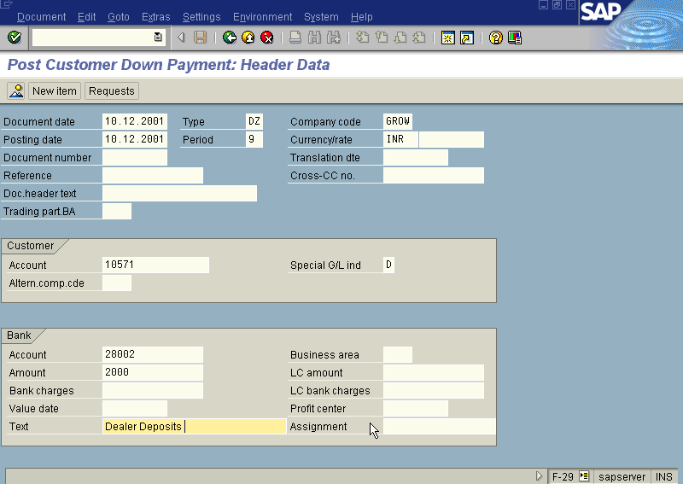
We get the Screen “Post Customer Down Payment - Header Data“ incorporating the above mentioned required fields as under;

Press Enter button

We get the Screen “Post Customer Down Payment - Add Customer Item” as under; where under Amount, Due date, fields to be entered.
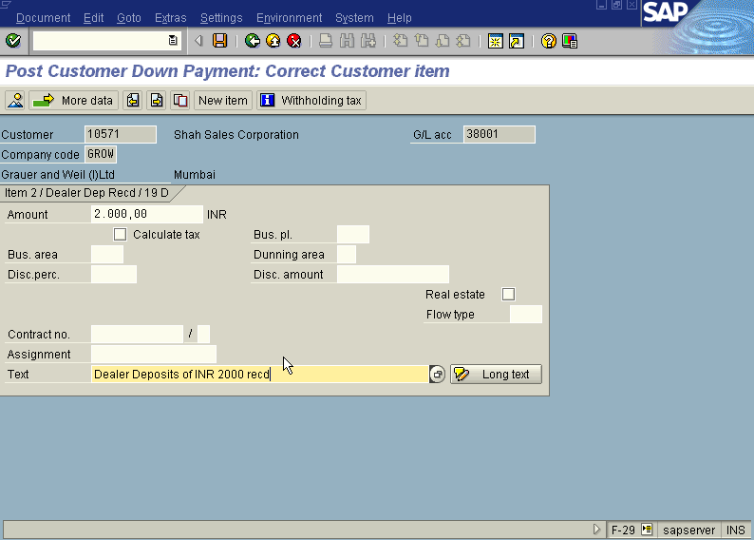

Press Enter button

Press Save button

The system will display a message as under: 1400147

Take a note of the document number ;

The document can be seen from Document Display from the top left hand side of the main screen “post Customer down payment - Header Data“ OR from Transaction code FB- 03 .The Document overview screen will be displayed as under showing the entries.

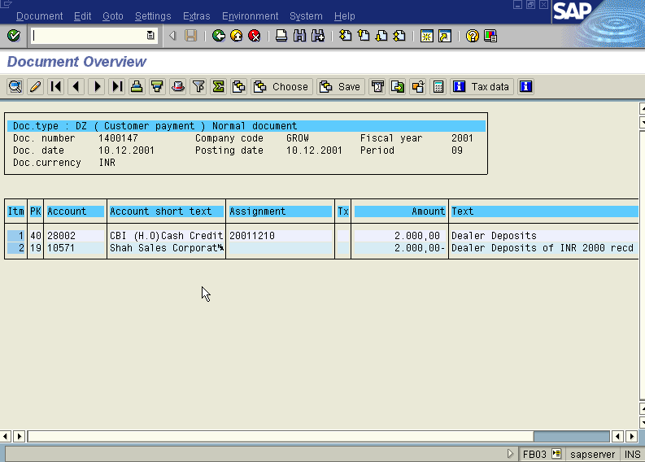

Step: 2 Sub Dealer doesn’t pay so we adjust against the dealer deposits of shah sales.

TRANSACTION CODE : F – 30

ACCESS PATH :SAP Easy Access →Accounting → Financial Accounting → Accounts Receivable → Document Entry →Other → Internal Transfer Posting → With Clearing.

We get the Screen “Post with Clearing - Header Data“ incorporating the above mentioned required fields as under;

In the above mentioned screen enter Document Date, Select the radio button Transfer Post with Clearing, posting Key (08) and Account Number of Sub Dealer (10028)

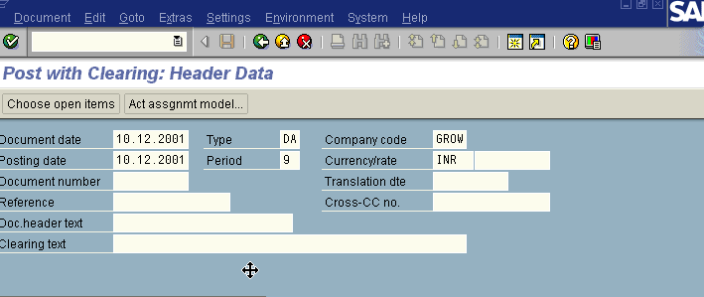
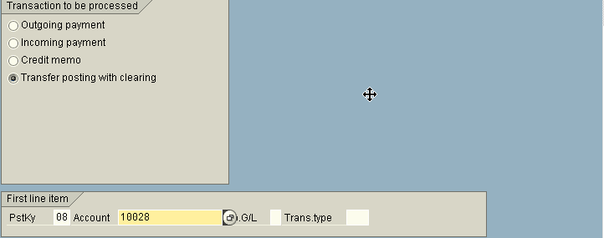

Press Enter or Choose Open Item Button

We get “ Post with Clearing – Add Customer Item” Screen

In the above screen don’t fill the amount field

Press Process Open Item Button

We get “Post with Clearing – Select Open Item” screen as under

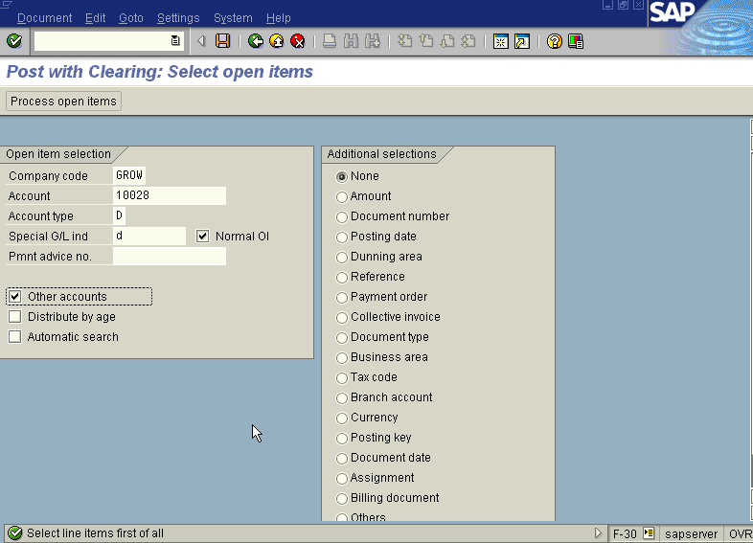
Press Enter

We get “ Additional Accounts “ Screen

In the above mentioned screen enter the main dealer account number (10571), Account Type (D), Company Code (GROW) and Spl. G/L Ind. (D) and screen is displayed as under
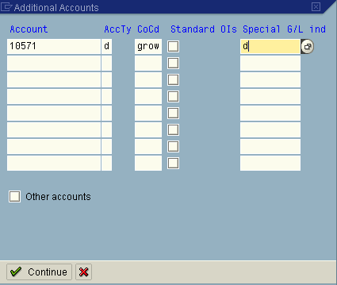

Press Continue Button

We get “ Post with Clearing – Process Open Item” Screen

In the above mentioned screen first select All icon and then press Deactivate icon and deactivate all the line items. So the Not Assigned Items becomes Zero.

Press Residue Items button

With help of field content search icon select two-document nos. Viz. Billing Doc. Account document no (10000692) and Down Payment doc No. (1400147). Double click on the amounts of the above stated documents the system will show a difference of INR45 in the column next to down payment amount double click with mouse the system displays the amount as (-45). Now the Not assigned portion changes to Zero.

Press save

The system displays the message as under

Take note of this document number – 1600232

The document can be seen from Document → Display from the top left hand side of the main screen “post Customer down payment - Header Data“ OR from Transaction code FB- 03 .The Document overview screen will be displayed as under showing the entries.
